ASE LAB 6

Deal Code Analysis with social login

In this application, I have two pages. Login page and Home page.

Login Page:

In this page, I have used facebook login sdk. I have Created new app and generated API key and provided the login page url, then we have to provide access to the app.

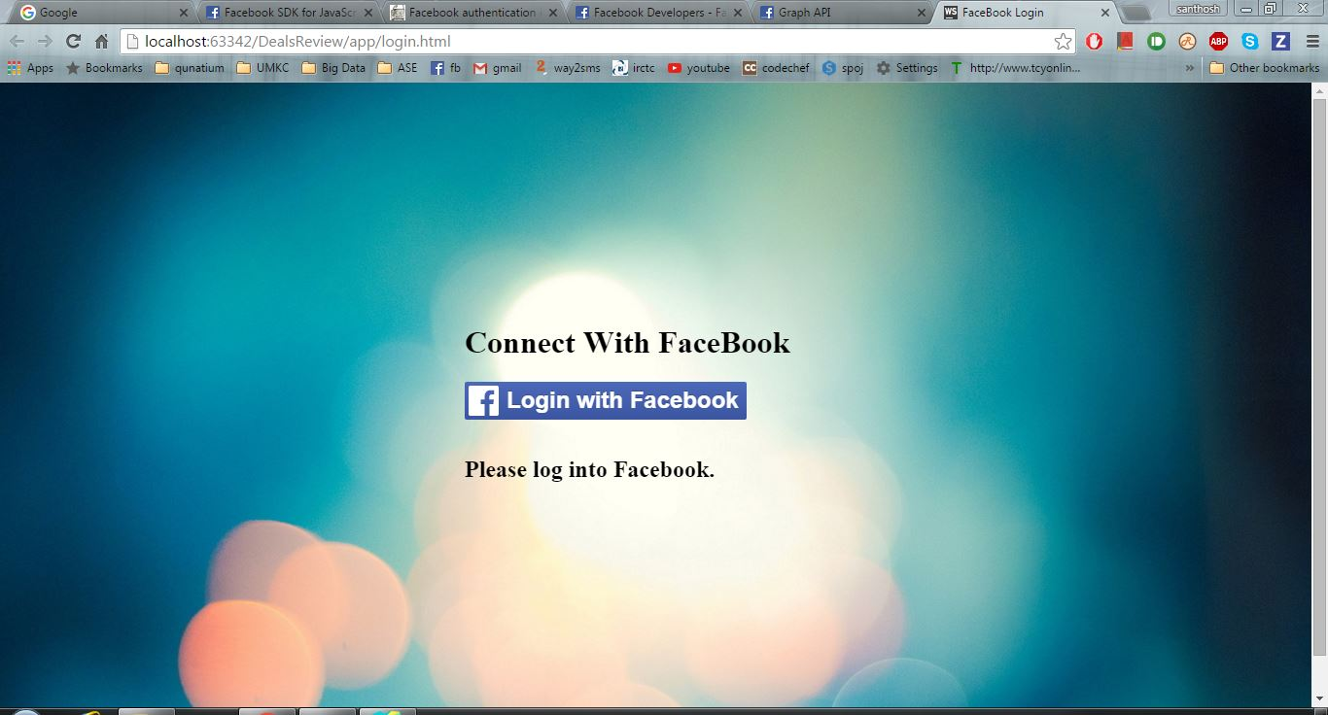

On clicking the button, a login page popup will be opened where username and password should be entered. On Successful login, username will be displayed in the login page and home page will be opened.

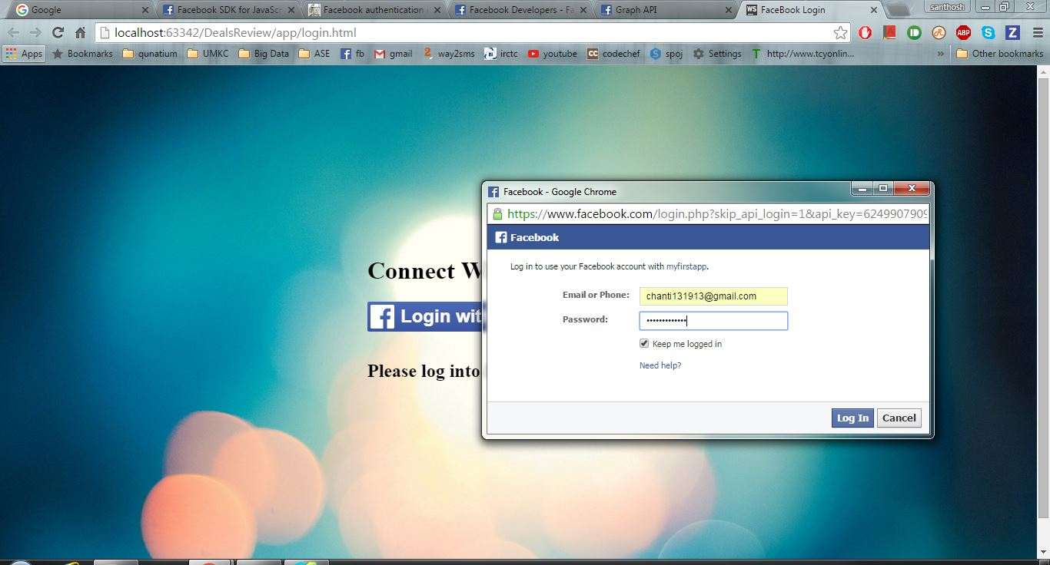

Fig: Login page with facebook popup

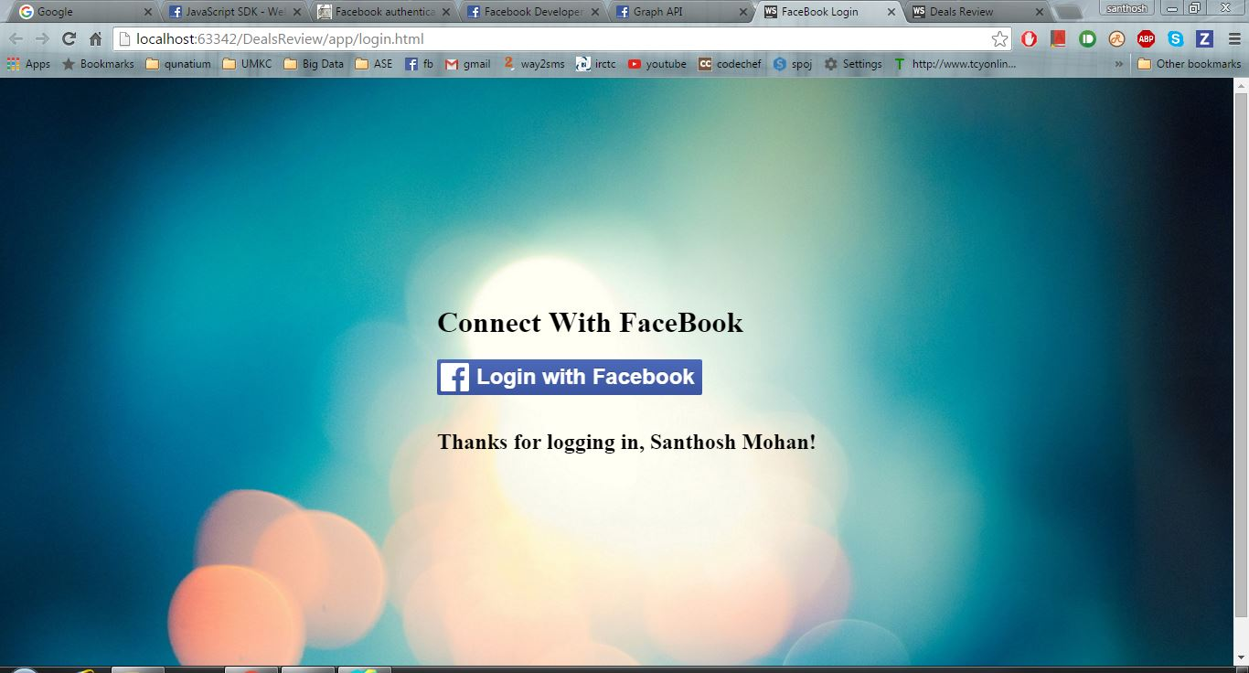

Fig : Login page with Username

**Home Page:**

On successful login, home page will be opened. This is the mashup page where you to enter the city name. Top deals will be displayed with category name and offer details. These details are provided by sqoot api. It is similar to DealsAround and Groupon.

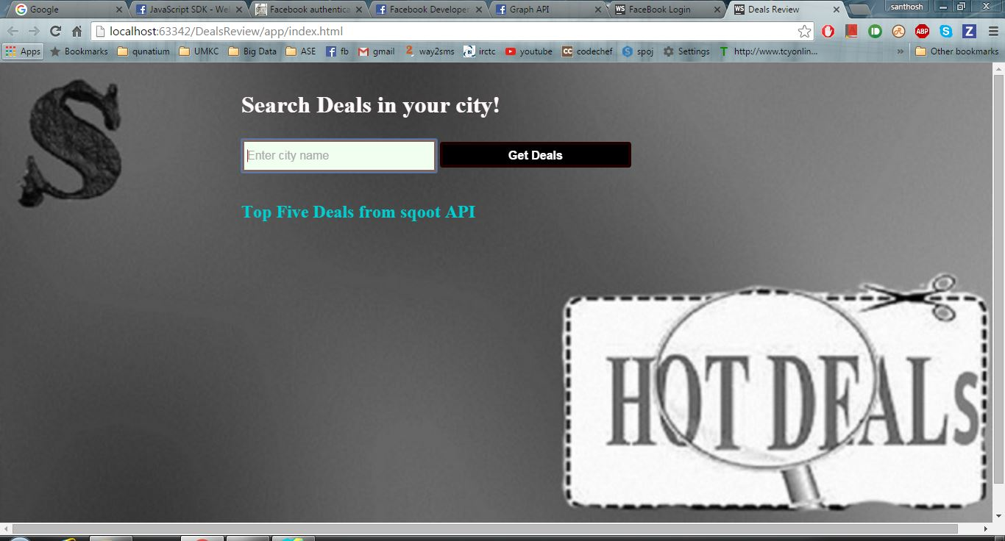

Fig: Home Page

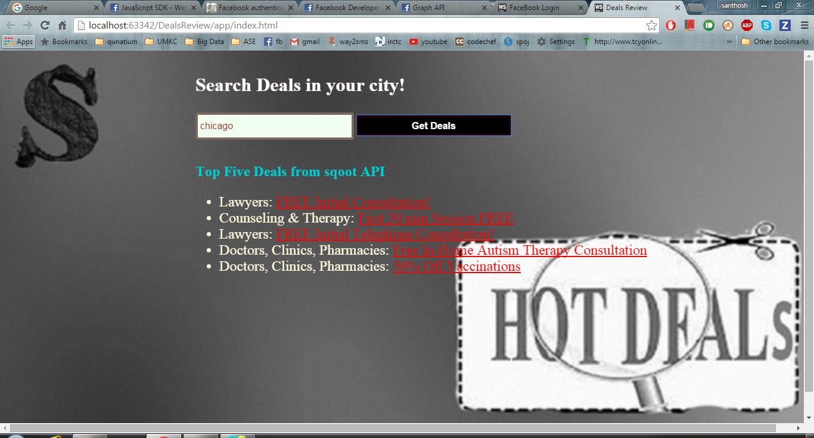

Fig: Top vouchers in the given city

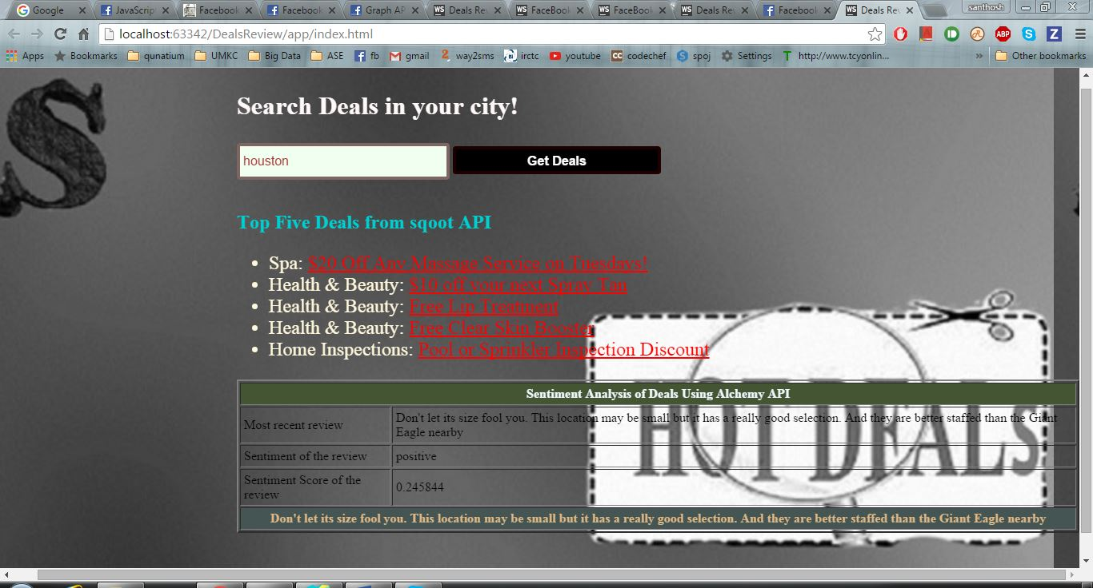

Fig: Sentimental analysis of the above vouchers.